Wazuh Detection Configuration

Wazuh is an open-source platform that provides extended detection response (XDR) and System Information and Event Management (SIEM). This project will showcase the creation of essential alerts detections. I will then demonstrate our alert detections through my network environment to simulate a possible threat that may need to be investigated.

SIEMS and XDR provide the following: Event Correlation, Real-time Alerts Intrusion Detection, and Endpoint Visibility
First, I created agent groups based on operating systems. These workstations will be connected to Wazuh to analyze data received from the agents. Wazuh will be my primary hub for security defense that will be used to log data and analyze traffic on the network.
The image below shows the agents connected to the group workstations (Linux, Windows)

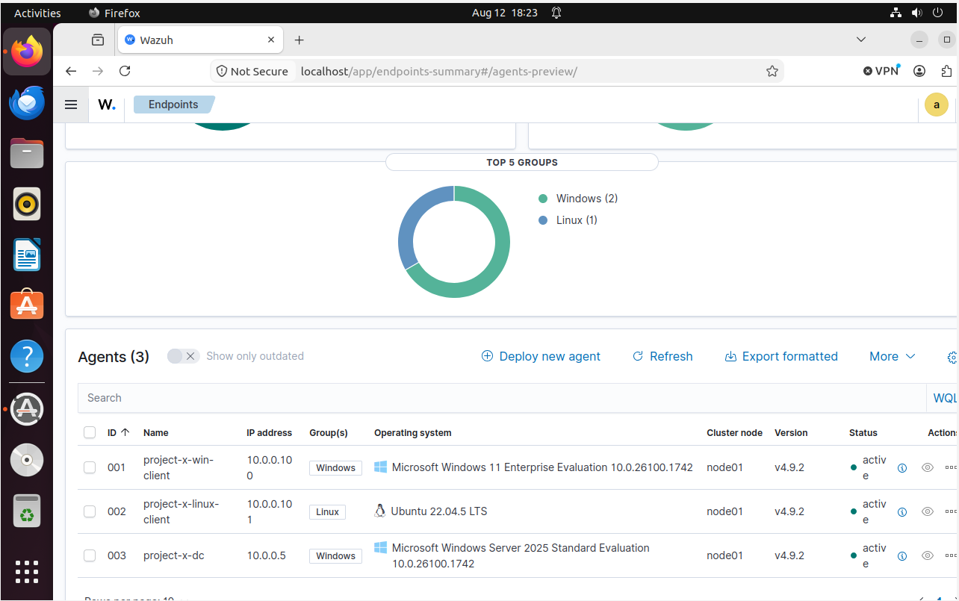

Authentication Attempts successful & Failures Through SSHD
Default Detection Alert Example
Wazuh has a default built-in rule detection for authentication failures. Below is an example of conducting a failed login attempt to demonstrate the alert on Wazuh. Notice the Timestamp Aug 17th @ 17:47
The first screenshot is the failure authentication attempt
The second screenshot is the alert of Wazuh detecting the activity ( note the timestamp and log notification for failed password).
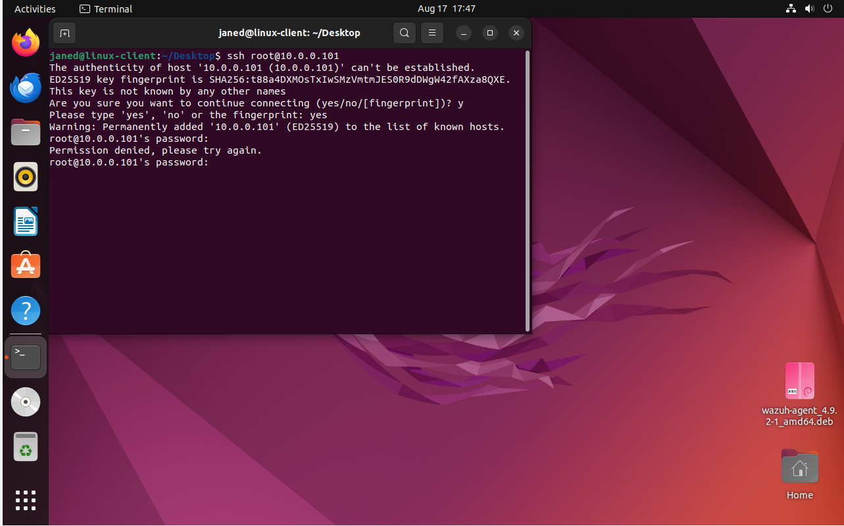
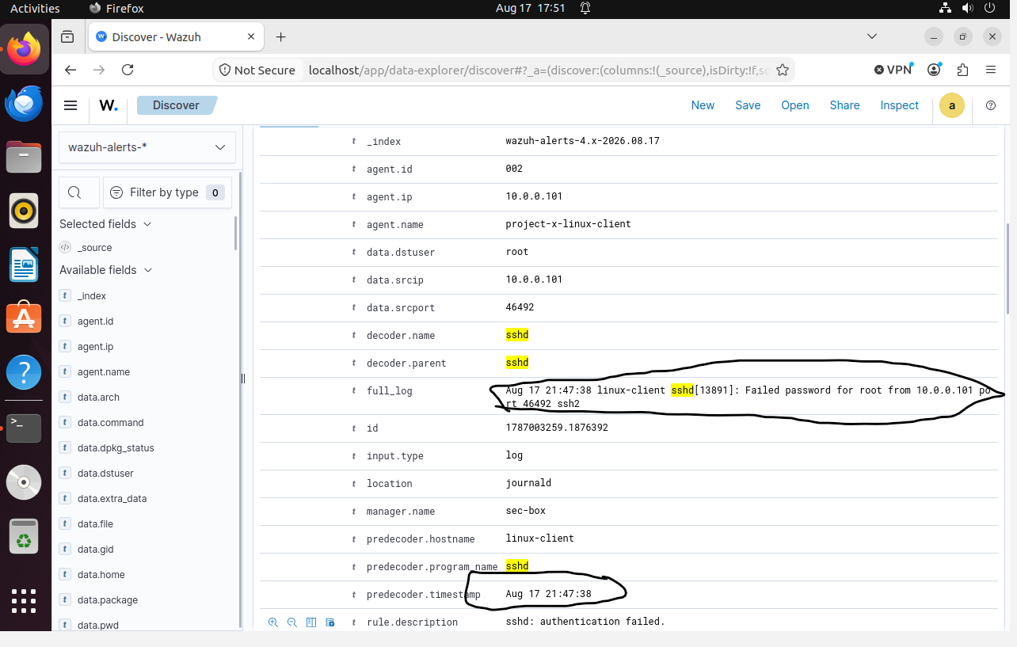

Detection Alert Creations
This section will be for the creation of my own alerts. My first alert will be triggered when 3 authentication attempts fail. Below is the screenshot of the creation. The screenshot below shows the creation.
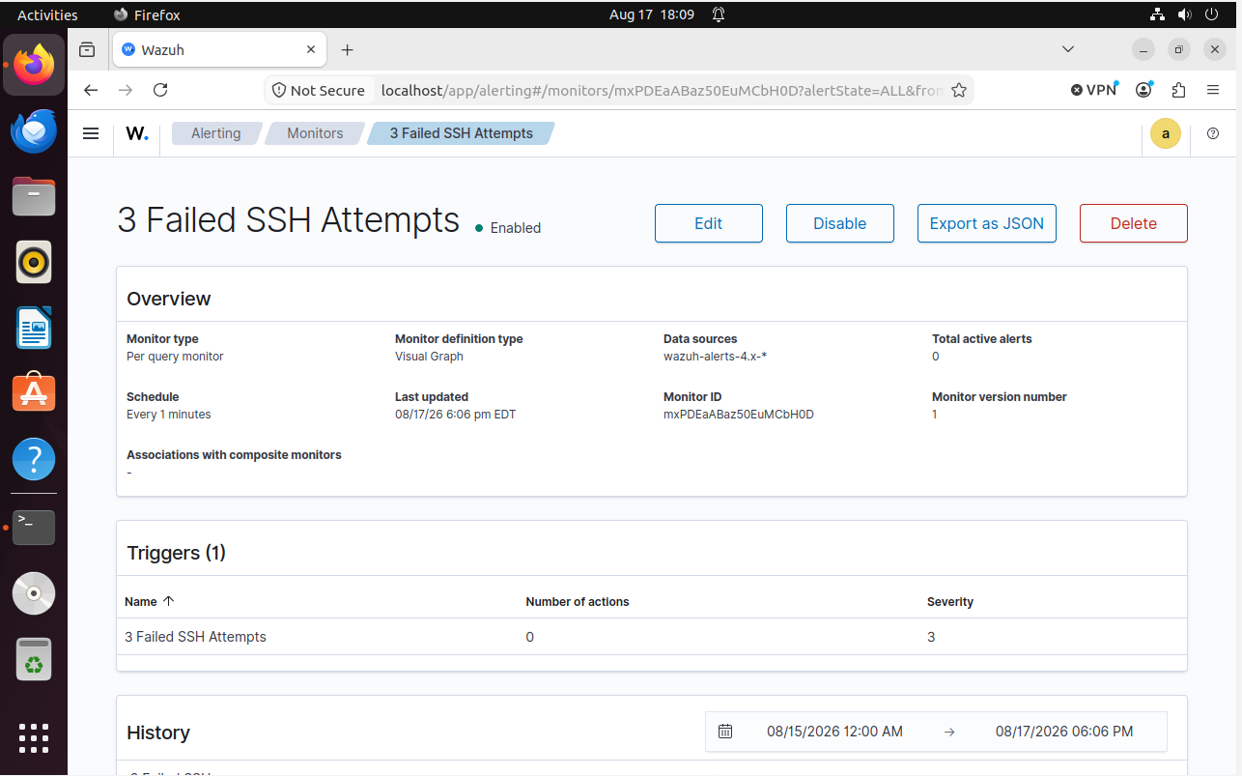

Another alert will be for WinRM to detect successful and unsuccessful authentication attempts into a Windows machine. The next alert will be modifications of files. The screenshot below shows the alerts created. The next lab will demonstrate these alerts along with the basic wazuh alerts configurations.
